**Version control systems(vcs)**

* Version control systems(vcs) are a category of software tools that help a software team manage changes to source code over time.
* Version control software keeps track of every modification to the code in a special kind of database.
* Version control is a software that allows you to manage changes over time
* Version control is also called revision control
* Version control is very much useful for developers / designers / writers
* Version control manage and tracks files
* Version control also help you to develop and ship products faster
* Git is a distributed version control system (DVCS)
* Each user has a local copy of the complete history of the project, which is known as a “repository”
* Users can work offline
* git helps us manage our project's files
* keeps track of our files
* used for team collaboration
* Can easily synchronize repositories
* git is a version control software which tracks computer files
* git helps us to work with other developers
* git helps to see what others are working on
* git helps to view your previous changes
* git helps to rollback to your previous code
* git contains many commands and some of them you should know

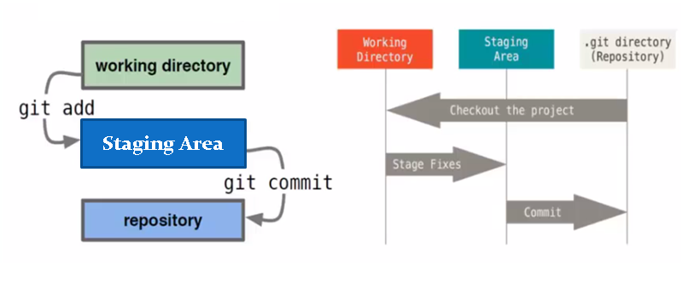

Git download and install:

<https://git-scm.com/downloads>

check it in cmd => open cmd

Type: git / git --version

Type for git help

git help

create a folder anywhere

goto folder and type (cd folder_name)

git status

it gives an error ==> not a git repository

next type => git init

Check the status whether git initialized or not

Create one file in that folder=> Test.text (to create a file or you can create in windows it self)

Open file ==> notepad test.txt => type some text/code

Then check status

no commits yet...untracked files

it means it is not gone to STAGING AREA

Next add to staging area

git add test.txt / git add .

now it is in staging area and we can track

Now change the file content and

check the status 🡺 git status

it shows modified in red color but not added to staging area (you need to add every time you change)

then check the status again, it will be added to stage, color green

git status

Now need to commit, with this we can create local repository and we get an id

Id is used as reference in future

git commit -m “first commit...”

Commited and its shows 1 file changed 1 insertion

now type => git status

it shows

on branch master

nothing to commit, working tree clean

Branches;

git branch xyz

event after creating branch, it shows master branch

to move to branch

git checkout xyz

now switched to xyz branch

git status

now change one of the file

git add .

git commit –m “updated”

switch to other branch(master)

git checkout master

open file from folder and see the content

other branch not effected.

merging branches:

------------------------

goto master

git merge xyz

git remote

it will not show anything because not linked with remote account

So

Create a account in github

In remote create a project /repository

Then add local to remote

git remote add https://github.com/sudhakarreddy2000/test.git

or short name

git remote add origin https://github.com/sudhakarreddy2000/test.git

To test remote => type => git remote

it should show origin

Now its time to push local repository to remote

git push -u origin master

now it is online

**Configure your Git username/email**

1. Open the command line.
2. Set your username:

git config --global user.name "FIRST_NAME LAST_NAME"

1. Set your email address:

git config --global user.email "MY_NAME@example.com"